Who: Anyone that has a shotgun and loves to shoot it
What: 10 Station 100 bird sporting clay shooting course
When: March 11th, 2017 at 9:00 AM
Where:
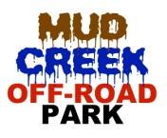
- 4 person team = $400 Please bring your own shotgun, shells, and ATV is recommended
- Shooters must be 18 and up
- Breakfast catered by Dairy Queen and Lunch catered by Sadler's Kitchen
- Mulligan available for purchase to replace lowest scoring station
- Team, Men, and Women awards will be given
- T-shirts will be given to all shooters
Team Name:___________________Phone:______________Email:______________________
Team Captain:_______________________________________________ Shirt Size_________
Shooter 2:__________________________________________________ Shirt Size_________
Shooter 3: __________________________________________________ Shirt Size_________
Shooter 4:__________________________________________________ Shirt Size_________
Kiwanis of Jacksonville would like to personally thank each shooter for their donation and for giving to the cause of helping the children in our community on an educational, physical and an emotional level. Your support to the Jacksonville Kiwanis Club is greatly appreciated.
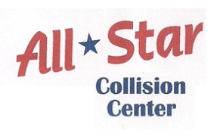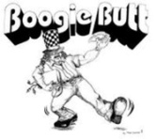

For more information contact Britian at info@jacksonvillecastle.com, (903)284-1859 Return forms to Kiwanis P.O. Box 8175, Jacksonville, TX 75766.

